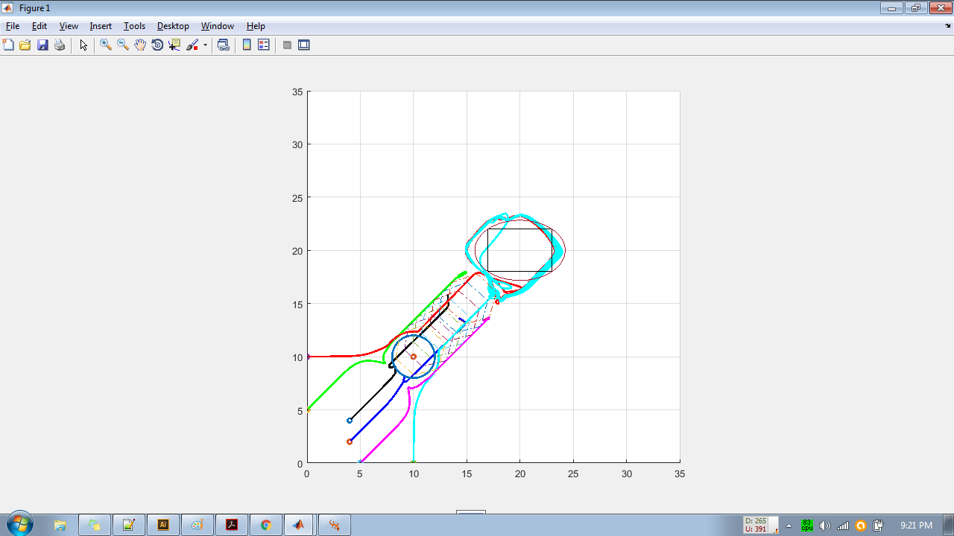

Virtual is waiting for robots to make formation to move forward, robots cannot form, cause of obstacle

FIXED force on virtual, 8,8

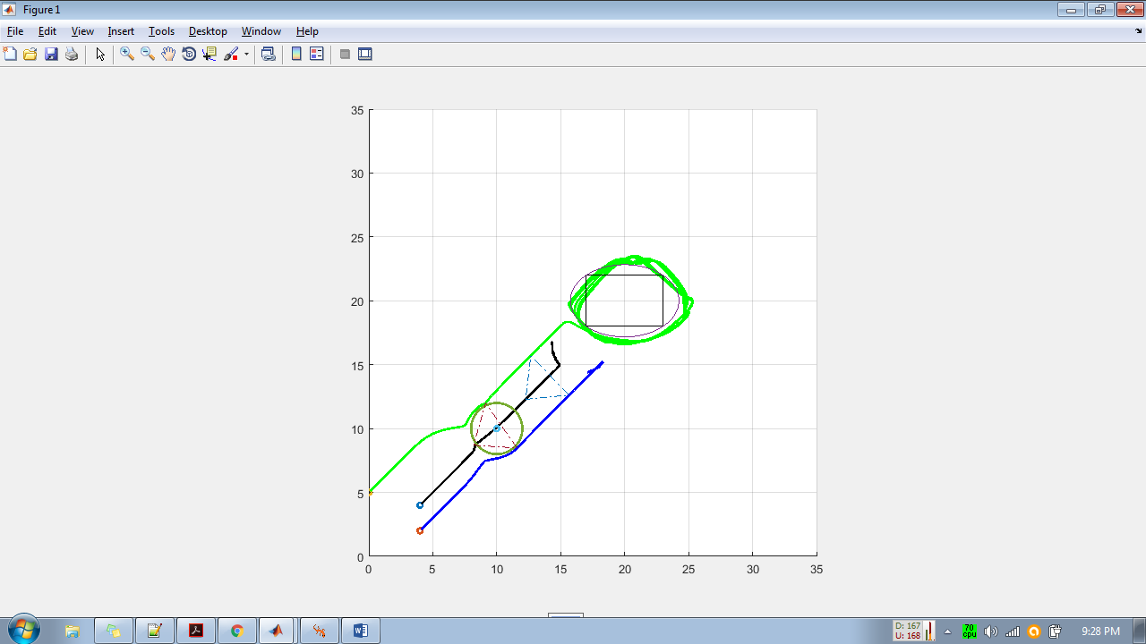

Same for 3 bots.

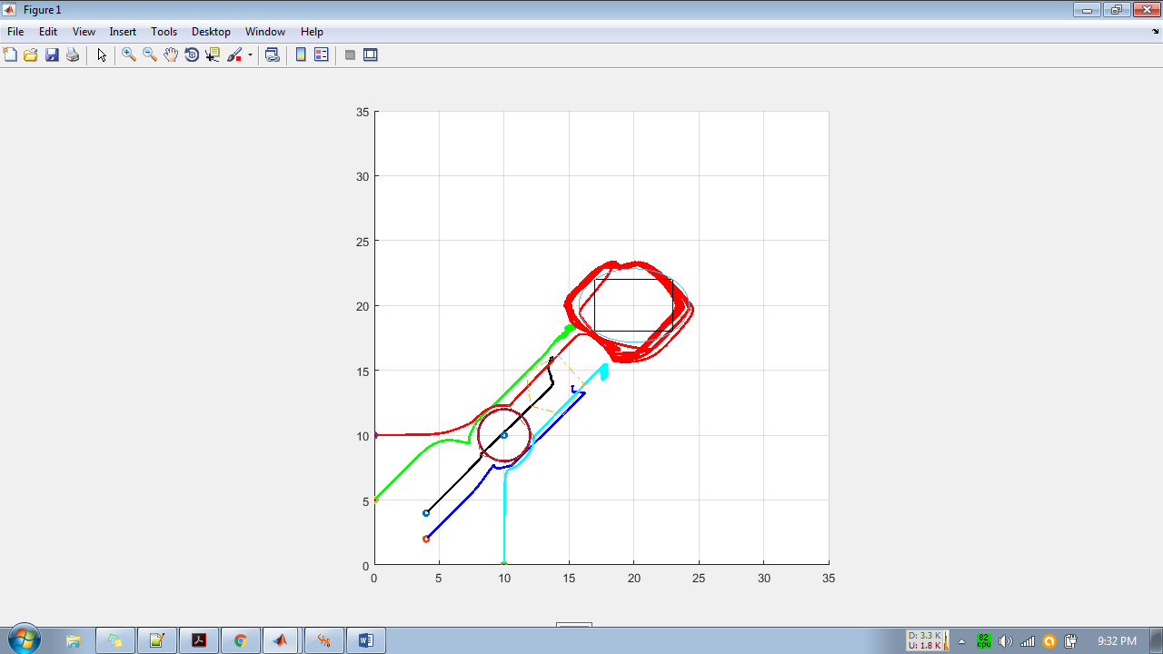

Same for 5 Bots

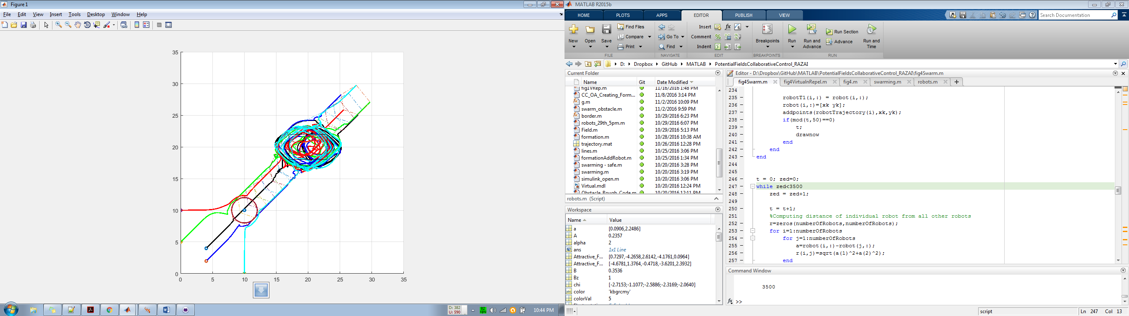

Made the virtual bot MOVE without stopping, only waits for SWARM formation at start, virtual bot force is also now 1,1

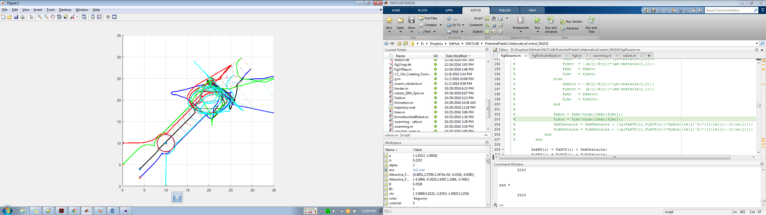

Something happened – some robots tried to avoid and some ignored the obstacle and then $hit happened.

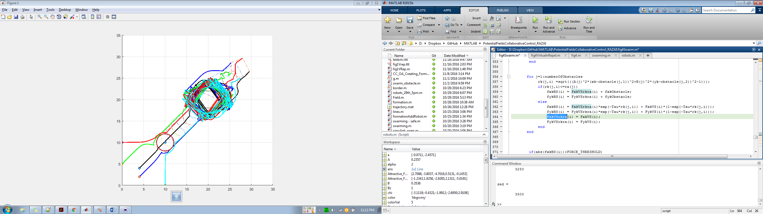

Seemed good enough until the robots moved AFTER the obstacle. – see next page.

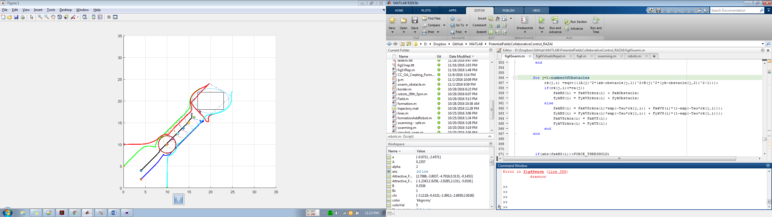

See HOW Red moves – this is concerning FxkVSrkra and FykVSrkra

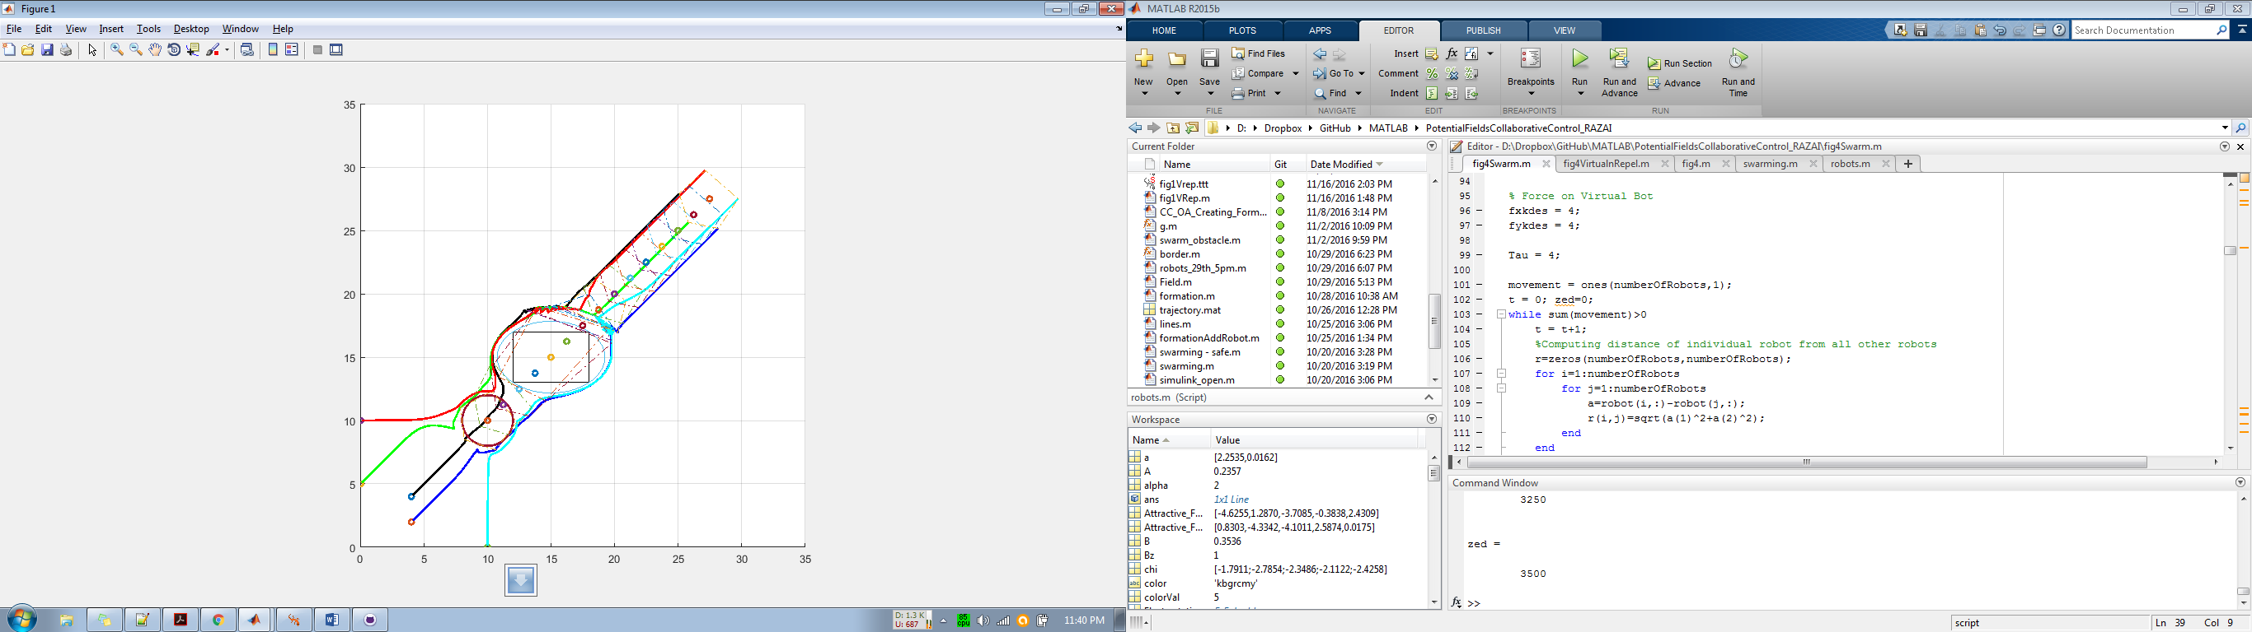

Virtual TOO Slow, but the others NOT colliding and then FORMING later on.

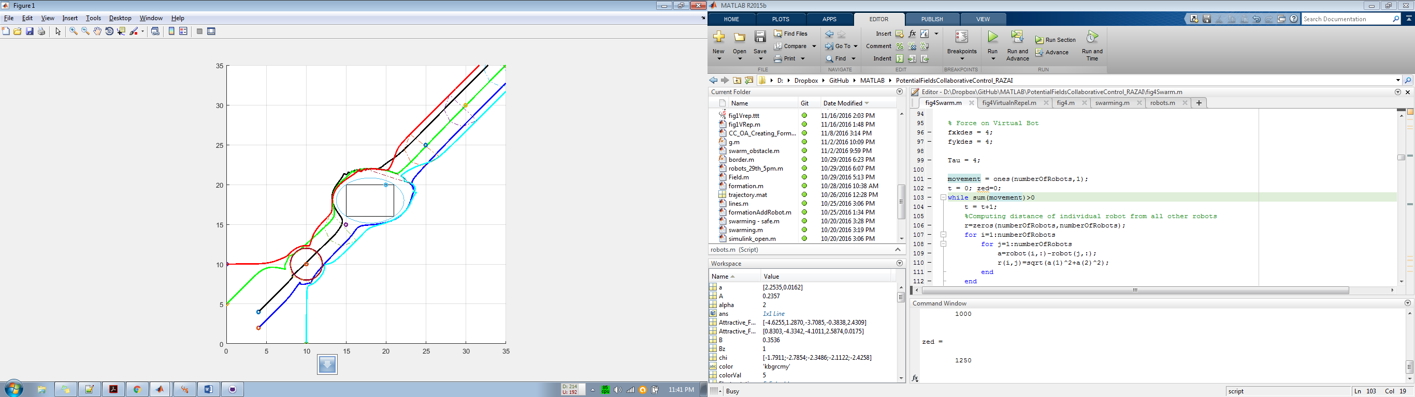

Virtual is FAST, swarm becomes at the back – formation maintained – obstacle cleared much better – need to add feedback to virtual force.